Explore

CAVES

& KARST

By

Christine V. McLelland

TABLE OF CONTENTS

National Science Education Standards: 3
TYPES OF CAVES & KARST 4
FORMED BY WATER (Solution Caves) 4
Speleothems 6
Other Cave Deposits: 8
Karst 9
FORMED BY THE OCEAN (Sea Caves) 10
FORMED BY LAVA (Lava Tubes) 11
FORMED BY GLACIERS (Glacier or Ice Caves) 12
FORMED BY EROSION 13
FORMED BY BACTERIA 14
CAVES AND PAST CLIMATES 14
SPELEOTHEMS 14
CAVE FOSSILS 16
CAVE LIFE 17
USES OF CAVES 18
Groundwater Contamination 20
Cave Tourism 21
Caves in the U.S. 21
CAVE CONSERVATION 22
NSS Conservation Policy 23
REFERENCES & RESOURCES: 27

National Science Education Standards:
Caves Teacher Notes, Student Activities, and Diagrams meet the following National Science Education Standards:

Content Standard D – Earth and Space Science
Levels 9-12
Geochemical cycles
Levels 5-8
Structure of the Earth system
Levels K-4
Changes in Earth and sky

Content Standard B - Physical Science Standards:
Levels 9-12
Chemical reactions
Structure and properties of matter
Levels 5-8
Properties and changes of properties in matter
Levels K-4
Properties of objects and materials

Content Standard E - Life Science Standards:
Levels 5-8
Populations and ecosystems
Levels K-4
Organisms and environments

Content Standard F – Science in Personal and Social Perspectives
Levels 9-12
Natural resources
Environmental quality
Levels 5-8
Populations, resources, and environments
Risk and benefits

TYPES OF CAVES & KARST

A cave is defined as a natural cavity that is formed underneath the Earth's surface. The cavity can range from a few meters (large enough for a human to fit into and long enough to be without daylight) to many kilometers in length and depth.

Karst is a distinct topography in which the dissolving action of water on rock results in unusual surface and subsurface features with vertical shafts, sinkholes, pits, gorges, disappearing streams, complex underground drainage systems, and/or caves.

The creation of caves is no simple matter. In fact, there are a number of different ways that caves can form. Caves are commonly formed from water, waves, or lava. Most recently, evidence has even been found suggesting that bacteria can also play a role in cave formation.

FORMED BY WATER (Solution Caves)
As water seeps through the ground, it absorbs carbon dioxide from decaying organic matter in the soil, forming a weak acid (carbonic acid).

H₂O + CO₂ = H₂CO₃
water + carbon dioxide = carbonic acid

On Earth there is a group of rock types that are predominately made up of carbonate minerals, such as calcite and aragonite (calcium carbonate) and dolomite (calcium-magnesium carbonate). This group of rocks, often referred to as carbonate rocks, includes the rock types limestone, marble, and dolostone.

When this slightly acidic water moves through cracks or layers in these carbonate rocks, the carbonic acid reacts with the calcite within the rock and dissolves it. Over time, acidic water can dissolve enough calcite that caves may begin to form.

H₂CO₃ + CaCO₃ = Ca⁺⁺ + 2 HCO³⁻
carbonic acid + calcite = calcium ion + hydrogen-carbonate ions

Water dissolves the rock as it passes through it under the surface, where it is present as groundwater. Warm groundwater can also percolate up into the rock from deeper in the Earth.

As the carbonate rock is dissolved, the cracks and fractures become larger. A maze of small passages may eventually be created. Groundwater may even start flowing as a stream, causing even more dissolution, and a large cave or a series of caverns may form. Most of these caves are referred to as limestone caves, although the original rock type may be dolostone. Caves formed in the metamorphic rock marble are called ‘marble caves’.

These groundwater caves typically have domed ceilings and rounded walls. They also can contain strange protrusions from the walls, ceilings, and floor that result from the rock being dissolved in three dimensions.

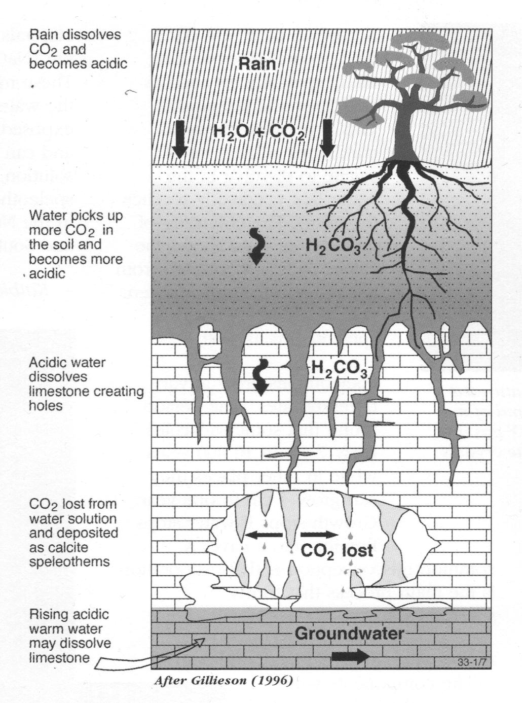
Adapted from “Discovering Cave” by AGSO

The entrance to a limestone cave is often carved from the cave's underground water flow. The groundwater can eventually carve its way through a hillside, creating an opening on the outside surface, often associated with a spring or waterfall. These form lateral entrances to the cave. Alternatively, if the pit and depression areas that are located at the top of a solution cave break through to the surface (or the overlying rock collapses) a collapse entrance or sinkhole can be formed above the cave.

Uplift of the land by tectonic forces, erosion (which allows the water to escape from the system along a new pathway), or lowering of the groundwater level may cause the water to drain from the system. Sinkholes are collapsed portions of the bedrock above a cave or open space from which the water has drained. Their size and depth varies dramatically. Sometimes other more resistant rocks are present, leaving an unusual topography as the softer rock dissolves away beside or beneath it.

Underground, even larger voids may develop. When groundwater drops in an area
(either by uplift, drought, or the pumping of water out of the system by human wells) an opening may become air filled. Springheads can then become cave entrances. Other voids never develop an entrance. Seeping of water from the surface and the change in the chemical equilibrium of the caves may cause them to then fill with dissolved minerals, forming cave formations, otherwise known as cave deposits or speleothems. Cycles of filling and emptying may also occur in these areas. Continued erosion of large voids may cause a roof to be too thin and collapse. This may expose the cave as a collapse sink with steep sides, or form a slump in the level of the land, a solution depression with shallow sloped sides.

Speleothems
Speleothems (from the Greek ‘spelion’ for cave and ‘theme’ for deposit) form as rainfall enters a void after passing through plant debris (humus) and carbonate bedrock. Speleothem types can include: stalagmites, stalactites, columns, straws, flowstones, shawls or many other varieties. There is a remarkable variety of speleothems in the world’s caves, and they are one of the reasons caving is quite popular.

The rate at which speleothems form depends upon the amount and rate of water entering the cave, the amount of acidity and minerals in the water, and the temperature and humidity conditions in the cave when the water enters. Most consist of calcite (calcium carbonate), which forms when carbon dioxide is released from cave water.

Ca⁺⁺ + 2 HCO³⁻ = CO₂ + CaCO₃ + H₂O
Calcium ion + hydrogen carbonate ions (both in solution) = carbon dioxide gas + calcite + water

Water rich in calcite, picked up from dissolving the limestone, is enriched with carbon dioxide as it enters the cave. When the carbonate-rich water enters an air-filled void, the carbon dioxide gas escapes from the water (like when we open a can of soda pop), reducing the acidity of the water, and releasing the calcium carbonate (CaCO₃) held in solution. Calcite is thus deposited into the cave.

Pure calcite is most commonly white. This color occurs when it is mixed with microscopic water or air molecules. It can occur in other colors, however, such as yellow-tan-brown (formed by impurities of tannic acid from decaying leaves, and other organic matter, or just plain dirt), reddish (from iron oxides), gray or black (from manganese or sometimes bat guano!), green (from copper or glauconite), and sometimes pink (from dolomite or organic materials). Large, pure crystals may be clear, and are called spar; those shaped specifically like a dog’s tooth are Icelandic Spar (or dogtooth). Sometimes smoke and soot from wildfires is blown into caves, staining formations black.

When speaking of speleothems, most people think first of stalactites and stalagmites.

Stalactites form from water droplets on the ceiling of a cave. Calcite collects around the edges of the droplet, forming a hollow tube, or soda straw, of crystallized calcite. Soda straws are quite common up to about a foot in length and (with the right conditions) have been known to grow to tens of feet. If the end of the straw becomes blocked, the water flows down the outside of the straw, forming a stalactite. A stalactite with water flowing on just one side may develop a thin drapery blade or one that looks like a curtain or a bacon rind.

Helictites are speleothems growing from the roof and walls that twist and curl around. One theory of their formation is that they grow as the result of capillary action, as the water seeps from the rock and is then pulled along through tiny, internal canals within the depositing crystal structure instead of yielding to gravity.

Stalagmites form when calcite-laden water hits the floor. The shapes of stalagmites depend on gravity (they are round tipped, whereas stalactites are pointy) and often have a splash cup at the end or otherwise resemble candles from the spatter of the mineral-laden water. Word play can help one remember which is which: stalactites hold tightly to the ceiling of a cave; stalagmites grow from the ground (you might trip over them).

Stalactites and stalagmites often grow in pairs, and sometimes grow together forming columns. But sometimes they grow singly, or in very uneven sizes. Stalactites that form over pools of water will not form stalagmites.

When water flows down cave walls or along the floors, sheets of calcite are deposited as flowstone. Sometimes the flowstone forms over loose gravel which is later washed away, leaving a ledge with nothing beneath it.

Cave pearls are rounded, polished speleothems consisting of concentric rings of calcite growing around a nucleus of sand.

Rimstone dams form on the edges of pools. As the pool fills to overflow, the water moves over the dam wall causing the carbon dioxide in the water to be released and as a result, a small amount of calcite is deposited on the dam. If the water moves too quickly the dam can be eroded.

Cave coral or popcorn are irregular clusters or rough knobs of crystalline calcium carbonate. It can form on walls and existing formations or on the floor and walls of pools, and is unusual because it can be deposited either above or below water. If an area is uniformly coated with coral, it is probable that it formed underwater. Sometimes the water in cave pools becomes so saturated with calcite that it simply falls out of solution because of the inability of the water to hold any more mineral in solution at that temperature.
Sub-aerial (formed in air) cave coral is actually more common than that formed in water. Cave coral may form in the air by:

1. water seeping through the bedrock;
2. thin films of water flowing over irregular surfaces;
3. splash from dripping water, and
4. water moving up walls by capillary action.

In very still water, calcite crystals may actually form on the surface, making calcite ice or rafts. These are quite fragile, and will sink at the slightest movement of the water.

Other Cave Deposits:
Minerals other than calcite, such as quartz, can be dissolved in water. These minerals are deposited when the solution undergoes a change in conditions and can no longer hold the mineral. Aragonite is similar to calcite but not as common and forms intricate shards and needles. Many salt and gypsum speleothems also form in caves. Selenite, a form of gypsum, often forms nests of fibrous crystals (needles), or long transparent rods. Gypsum can also form gypsum crystal chandeliers, such as found in Lechuguilla Cave at Carlsbad Caverns National Park. Sulfates of sodium and magnesium, iron minerals such as limonite and goethite, manganese minerals, barite, celestite, and more than fifty other minerals also occur in caves.

There are many kinds of cave clay. The red, sticky clay (known as unctuous clay) comes from decomposed dolomite, which is why it persists along ceiling shelves and out of the way places. This clay is red because of the minerals it contains (mostly magnesium and iron aluminosilicates bound with hydroxyl ions). Cracked speleothems, which are later recemented, often occur as a result of the clay cave floor drying out and shrinking, thus lowering the floor level. Other clays can be found in caves and can be blue, gray or brown in color.

Brown mud (actually soil and humus) washes in from the outside, both through the ceiling and during periods of high water in caves. Both cave clay and mud may preserve animal tracks and bones, both ancient and modern, as seen in some Missouri caves. Cave fills are particularly noteworthy because they contain materials that reflect a geologic history and a record of past climates of the surrounding area.

Corrosion residues may be the breakdown product of the corrosion of limestone walls or the metabolic waste of bacteria. Corrosion residues occur in many colors, including black, gun metal gray, red, brown, yellow, ocher, pink, and orange and may form a layer a millimeter to more than a centimeter thick on walls and ceilings. The latest research has shown that black residues contain the highest concentration of manganese oxides, while reds and browns contain the highest amounts of iron oxides. The calcium carbonate associated with corrosion residues shows pitting of various types, including pits in the wall rock behind the corrosion residues that contain putative bacterial filaments. Corrosion residues on walls and ceilings of Lechuguilla and Spider Caves in Carlsbad Caverns National Park were discovered to contain these filamentous materials suggestive of bacterial and fungal life. Preliminary evidence suggests that the diverse community of microorganisms inhabiting corrosion residues includes fungi and bacteria that live by using manganese and iron. Other bacterial morphologies have been observed in corrosion residues. Corrosion residues are also found in Jewel Cave, Jewel Cave National Monument, Wind Cave National Park, and other dry caves in the western U.S.

Rock material produced by the collapse of the ceiling or walls of a cave is called breakdown and may range in size from plates and chips to massive blocks. Most breakdown present in caves today appears to have occurred thousands of years ago. It is generally associated with the early history of cave development.

There are many other cave formations, including broomsticks, spar, showerheads, draperies, bathtubs, balloons, splattermites, and others. Many of these are quite rare. An excellent web site to view photos of cave formations from all over the world is Dave Bunnell's “The Virtual Cave” at: http://www.goodearthgraphics.com/virtcave/index.html.

Karst
Karst is a term that was first applied to the karst region of Slovenia. It has now come to be applied to similar regions throughout the world. Such regions are characterized by the presence of limestone or other soluble rocks (not always carbonates), where drainage has been largely diverted into subterranean routes. The topography of such areas is dominated by sinkholes, sinking streams, large springs, tunnels, and caves, all formed by water.

Each karst system has many different variables, including climate and temperature of the region, and the mechanical and chemical structure of the rock. Typically these areas have rolling hills, deep hollows, and the features listed above.

In karst areas, the bedding planes, joints, folds, and faults in the rock often control water flow. They can produce passages that allow water flow in directions completely independent of the surface shape of the hills and valleys. Water can even flow between the valleys through caves, and uphill under pressure. If it reaches the land surface, a spring may emerge, even on a high cliff. In karst areas, spring drainage often has little to do with surface drainage, because the water movement is actually groundwater movement, not surface movement. Sometimes water flow is tested by putting a harmless fluorescent dye into water where it enters a cave system, and determining where it resurfaces above ground. This helps determine groundwater flow in the area. This is important for people using the groundwater, and especially if sources of contaminants could enter groundwater flow paths.

As dissolution of the bedrock continues, the conduits through which the water flows may become larger, allowing more water and more dissolution (and abrasion by faster flowing water) to occur. Karst pinnacles are tapered columns of rock created as water dissolves the rock along joint fractures, leaving a strange pattern of columns still standing. This type of karst can take a very long time to develop.
Evaporites are the most soluble of common rocks. They are dissolved readily to form the same types of karst features that commonly are found in limestones and dolomites. Evaporites, including gypsum (or anhydrite) and salt, are present in 32 of the 48 contiguous United States, and they underlie about 35–40% of the land area. Evaporite karst features typical in outcrops include sinkholes, caves, disappearing streams, and springs. Other evidence of active evaporite karst includes surface-collapse structures and saline springs or saline plumes that result from salt dissolution. Many evaporites also contain evidence of paleokarst (ancient karst), such as dissolution breccias, breccia pipes, slumped beds, and collapse structures, formed long before the newer karst structures.
Karst areas do not retain water easily and therefore develop poor soils and can be sources of engineering or environmental problems. They do make for dramatic topography, but are vulnerable to incompatible or damaging uses. Groundwater contamination can occur quickly and be difficult to remediate. Many karst areas are on private land, sometimes with owners apathetic to their preservation or unaware of their significance. They can be dangerous sites to build on, since the land may not be able to support structures or water and septic systems. Dangerous sinkholes and caves can form rapidly, or preexisting karst features can be reactivated and open up (collapse) under certain hydrologic conditions or when the land is put to new uses. Human activities also have caused development of evaporite karst, primarily in salt deposits. Boreholes (petroleum tests or solution-mining operations) or underground mines may enable unsaturated water to flow through or against salt deposits, either intentionally or inadvertently, thus allowing development of small to large dissolution cavities. If the dissolution cavity is large enough and shallow enough, successive roof failures can cause land subsidence and catastrophic collapse.

FORMED BY THE OCEAN (Sea Caves)
Sea or anchialine caves are found all over the world and are arguably the most numerous of all cave types. They are formed by the wave and water action of the sea attacking seaside cliffs. The rock may be dissolved away by the seawater, or may be eroded by the action of the waves and the sediment the waves carry. Sea caves are usually formed where there is a zone of weakness in the coastal bedrock, a fault or fracture zone, or where weaker rock is interbedded with harder rock. The rock gets eroded more and more quickly as the surface area of the crack or fracture expands from the force of the water and sand.

Sea caves can be quite dramatic, with access sometimes only by boat, kayak or swimming. Timing also may be key, as they can become completely flooded during high tide and exposed only at low tide. They rarely have the speleothems found in solution caves or lava tubes, and are often long and narrow. Sea caves do, however, abound with life, from algae and barnacles growing on the cave walls, to starfish, anemone, crustaceans, and sponges on the floors and lower walls. Even fish can survive in caves that do not totally empty out. These caves can also be inhabited by a diverse array of previously unknown species from a number of new higher taxa. The world’s longest sea cave is Painted Cave in Santa Cruz Island, California, which is 1227 feet long (374 m).

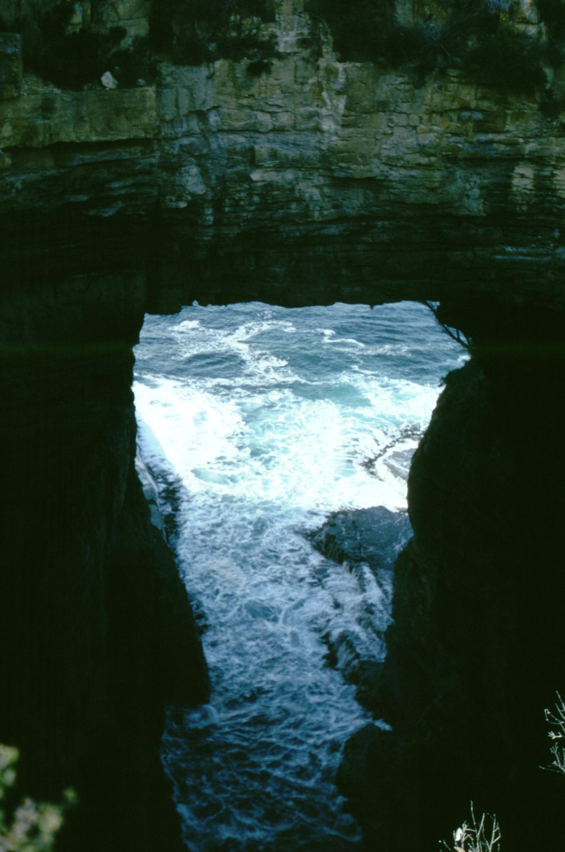
Sea Cave in Tasmania, Australia (Image: Gary Lewis)

Sometimes sea caves can form a collapse on the landward end. When high seas or high waves move into these caves, the air in the cave can become compressed and as the wave rolls back the compressed air escapes with some of the sea water through the collapse hole with a mighty gush. These are known as blowholes.

FORMED BY LAVA (Lava Tubes)
In areas of basaltic volcanic activity, magma rises from deep in the earth and may eventually reach the surface. In certain areas of the world, this magma is very fluid, and flows out of the ground to become lava, flowing like a river down the surface of the Earth. Lava tubes are formed when the top and edges of a molten lava river cool and harden to form a basalt tunnel. Lava continues to flow through the tunnel until the source is depleted. The inner walls may become thicker by subsequent lava flows. Lava caves may be simple tubes or extensive labyrinths that extend for miles. They are found in the western United States, Canary Islands, Iceland, Italy, Korea, Japan, Kenya, Australia, and Hawaii and other Pacific Islands.

The tubes also can contain speleothems, as in limestone caves. Stalactites, stalagmites, flowstone, columns, straws and helictites made of basalt can form while the tube is still active and molten material drips down from the cave sides. These are referred to as primary formations. Secondary formations include mineral deposits, such as calcite and gypsum, which tend to be much smaller than primary formations. Secondary formations can include stalactites, stalagmites, and other formations listed in solution cave formations.

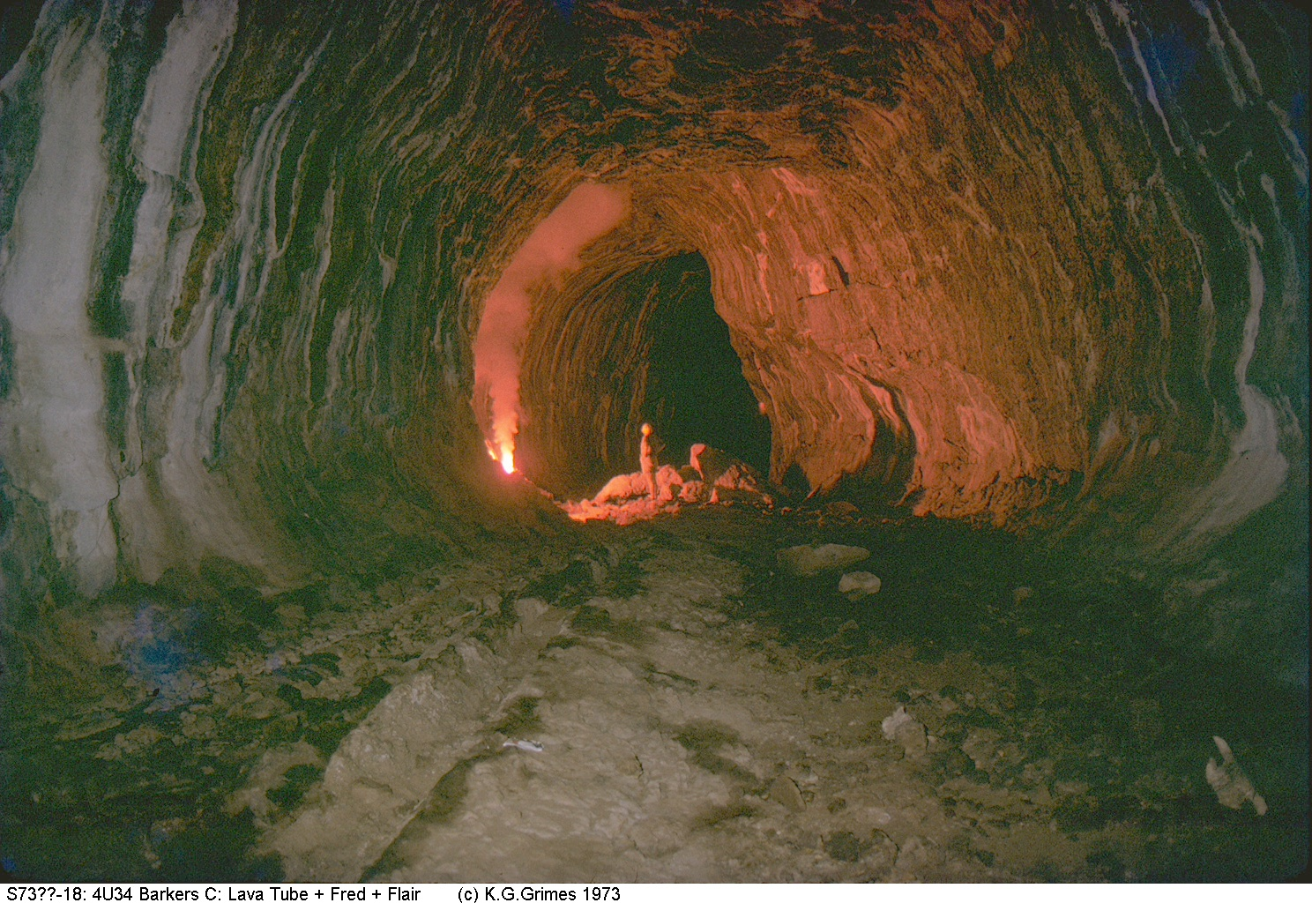

Other interesting features can form. Braided mazes are where two or more tunnels converge or diverge, usually occurring where the slope is shallow. Braids tend to rejoin into one larger tube. Skylights can form where breakdown has occurred, pieces of the ceiling falling onto the floor (this often occurs in the later cooling stages of the cave as the rock contracts). Lava falls can form where the lava flows over a drop in elevation, and lava lakes can pool under the falls. Lava balls form from breakdown of the ceiling which then may keep rolling, accumulating more lava like a snowball rolling down a snow-covered hill. Many more features can be found in these caves.

Lava caves are delicate and unique. Unfortunately, some have been used for garbage dumping which is now illegal in some states and countries. Others have been used historically for burial grounds, homes, and religious practices. Some even contain petroglyphs and pictographs.

FORMED BY GLACIERS (Glacier or Ice Caves)
Glacier caves are formed in ice by melt water that becomes a river beneath the glacier and flows out at the foot, creating a cave. In some areas of Iceland, where glacial ice is juxtaposed above volcanically active land, some glacier caves can provide access to hot springs beneath vast amounts of ice. Glacial caves are, however, often short-lived before the ice collapses, moves, or melts. Ice caves are being actively explored in Greenland by French speleologists.

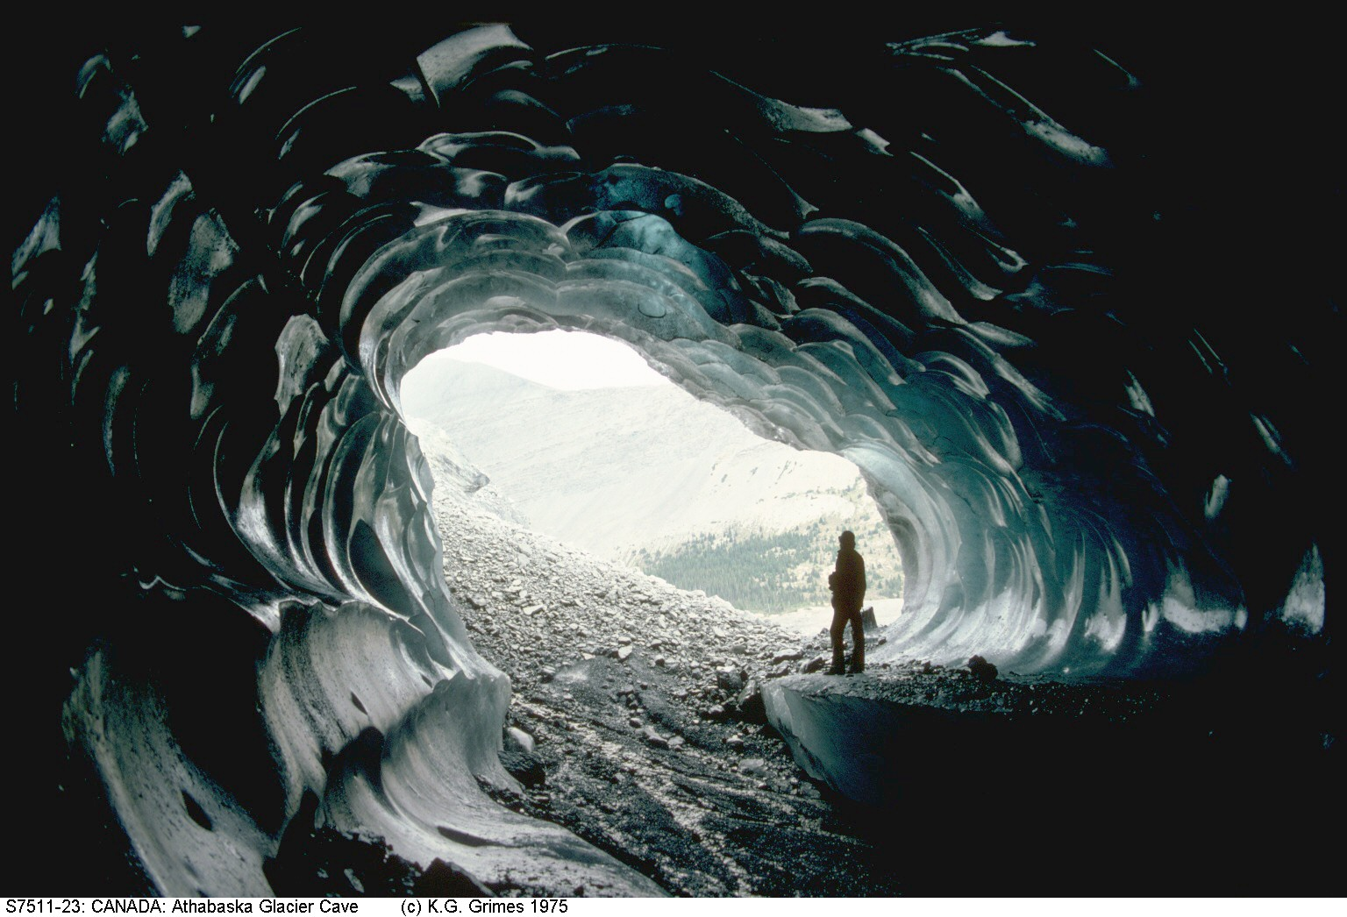

FORMED BY EROSION
Glacial caves, described above, are formed by the erosional power of flowing water, and could be considered erosional caves. Water can also erode caves out of granite and sandstone, as well as other “hard” rocks. The action of flash floods combined with wind-blown sand has created beautiful and large caves in the desert southwest. Though not as common, there are caves formed mainly by wind. Some so called “wind caves” (e. g., Cave of the Winds, Colorado), however, are not originally formed by wind, but instead have strong currents of wind blowing through them. Erosional caves are not usually deep or extensive, but tend to be tall and canyon-like. They are believed to initially form along a zone of weakness in the rocks, such as a weak bedding plane, fracture, or fault, which is exploited by water and wind action. They aren’t associated with speleothems since the erosional action would prohibit such structures from forming.

FORMED BY BACTERIA
Recent evidence has shown that certain bacteria, called extremophiles because they live in extreme conditions, can eat away at limestone and possibly form caves or at least make them bigger. The process involves extremophiles that digest oil found in the pores of rocks. As part of their digestion processes, the bacteria expel hydrogen sulfide gas. This gas mixes with the groundwater forming sulfuric acid which eats away at the limestone, enlarging the space. Other bacteria within the space can also feed off the hydrogen sulfide, creating more sulfuric acid. For additional information on the bacteria, see Cave Life below.

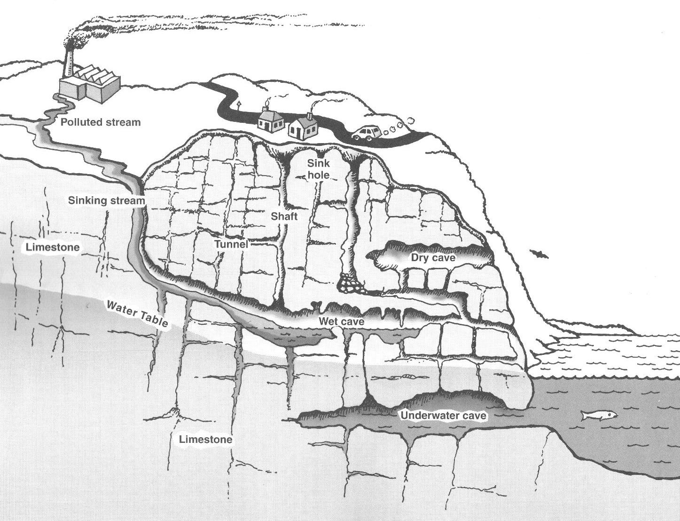

From USGS Exploring caves

CAVES AND PAST CLIMATES

SPELEOTHEMS
The rate at which speleothems form depends upon the amount and rate of water entering the cave, the amount of acidity and minerals in the water, and the temperature and humidity conditions in the cave when the water enters it. Studying speleothems, therefore, may give an indication of the past climates (particularly the temperature and humidity) in the cave and thus the area, a veritable history in minerals. Growth of speleothems is seasonal, dependent on water volume and the number and type of particles. As a result, formations develop a stratified structure that reflects their environment rather like tree rings. Simply put, when rainfall is high, speleothems grow quickly. In drier or cooler times, growth slows. If there is no growth, then flow of groundwater stopped completely, perhaps during drought or glacial periods. Scientists can determine fast, slow, or no growth by radiometrically dating the bands of calcite. Speleothems contain very small amounts of Uranium 238 (U²³⁸), previously dissolved in the initial rainwater. The uranium decays radioactively into U²³⁴ and then into Thorium 230 (Th²³⁰) at a known rate. So the thorium/uranium ratio accurately indicates the age of the deposit.

Oxygen and carbon isotope studies can also provide information about the climate conditions at the time of speleothem formation. Most caves have air temperatures close to the annual average that occurs on the surface. The oxygen in the deposited limestone is either the normal isotope O¹⁶, or ‘heavy oxygen’ O¹⁸, according to the surface temperature from which the oxygen came into the cave in the water. At higher temperatures, there is a higher proportion of O¹⁶ to O¹⁸. Likewise, the ratio of two carbon isotopes in the deposit depends on soil conditions and vegetation types around the time of deposition, and hence, indirectly, on ambient temperatures at that time. In short, measuring the three isotope ratios of layers within a speleothem shows climatic conditions in the past.

Recently, evidence of climate change was derived from stalagmites from Carlsbad Caverns, New Mexico. Two scientists measured the thickness of calcite bands in stalagmites to create an annual record of rainfall in the region for the past 4,000 years. They found that the start of wetter or drier periods corresponded with major agricultural advances in the local native population. For example, a wetter period starting around 1000 B.C. coincided with the rise of corn agriculture, and a drier period in 300 A.D. coincided with ceramics production. Measurements of stalagmites in New Zealand showed clearly the glacial maximum in that area at 20,000 years ago, and a smaller cold period around 12,000 B.C.

A group of scientists from the University of Alabama is working in caves on a small Polynesian island, Niue, in the Pacific. The island is made from a coral reef, and the caves have a constant temperature, reflecting the average yearly surface temperature of the surrounding ocean. The island is too far from any continent to be affected by a landmass. Therefore, the cave temperature will only change if the whole climate of the area changes. By studying the speleothems in the cave, they can study the climate of the Pacific Ocean in the area over time, which happens to be effected strongly by El Nio (El Nio refers to a temporary change in the Pacific Ocean's climate, specifically the area of the ocean near the equator). El Nio is one of the major factors affecting climatic changes worldwide. Studying the isotope ratios can help the scientists learn more about previous El Nio occurrences, and hopefully provide insight into whether the planet's recent temperature elevations are part of the natural cycle or whether they are a result of man-made activities that are changing the environment.

Looking at the holes in calcite deposits can give an indication of the water conditions of deposition. Dense calcite with no air holes is deposited in air-filled caves. Calcite deposited in seawater-filled caves is full of holes. This can give an indication of the level of the sea at various times in a cave’s formation.

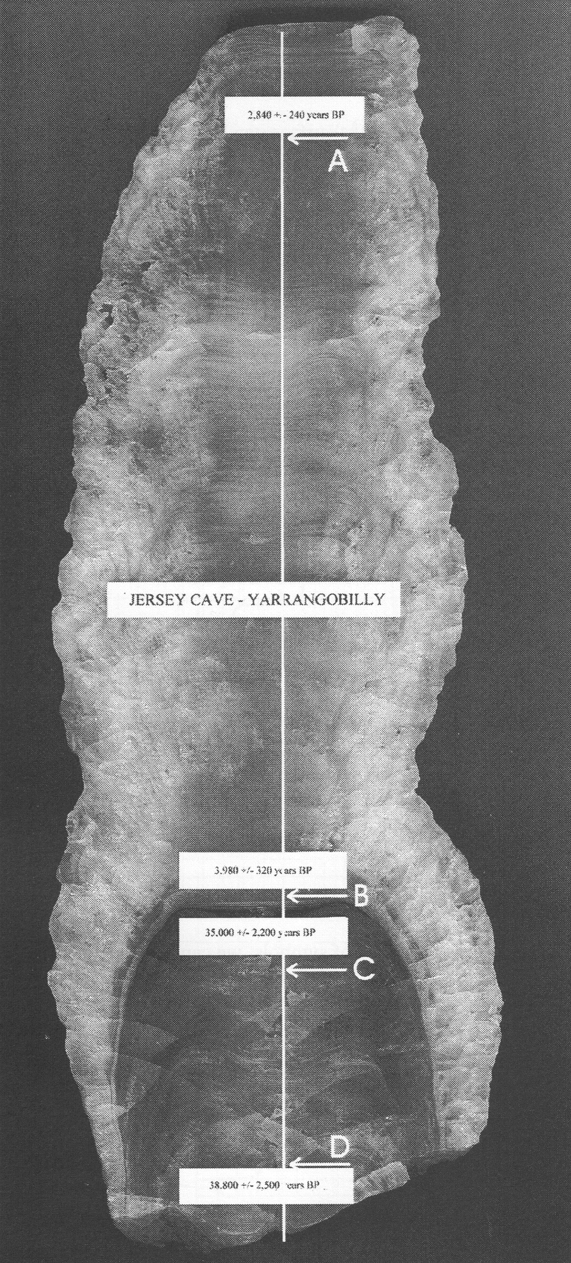

Cross section through a stalagmite showing areas dated by scientists (Image by Andy Spate).

CAVE FOSSILS
Fossils and animal and plant remains in caves can also indicate climates. Cave walls can expose fossils that were part of the limestone when it was formed. Although not an indication of the climate at the time of the cave formation, these fossils can be invaluable to determining the climate and geologic time when the limestone was deposited. Fossils found in caves are mainly marine life, such as coral, nautiloids, brachiopods, etc. But fossils aren’t the only form of deceased life found in caves. Since dry caves are often well-protected areas, not exposed to scavengers, wind, rain, sun, etc., any animal that somehow drops into or climbs into a cave and dies there may be well preserved. Even cave water does not dissolve bone quickly. In Australia, for example, important fossil finds, unique to Australia, within caves in the 1800s convinced people that animals species had changed and evolved over time.

CAVE LIFE
Caves contain a wide variety of life forms, vertebrates and invertebrates alike. Species that evolve in caves are often unusual. Cave dwelling animals include species of fish, crayfish, salamanders and frogs, birds, worms, spiders, centipedes and millipedes, scorpions, sponges, and insects, many of which are often uniquely adapted to the cave environment.

Bats are probably the most familiar of cave occupants. They are called trogloxenes (“cave guests”), meaning they live in caves but need to leave them to find food, and can live elsewhere. Because bats use echolocation to find their way they are well suited for living in the dark, far from the entrances of caves. They do tend to head toward the top of the cave to sleep, rest and bear their young because heat rises and gets trapped in domed ceilings. They may also change caves according to the time of year and season. In the winter they may hibernate, allowing the body temperature, heart, and breathing rates to decrease to conserve energy. Bat guano (their waste product) will fall on the walls and floor of the cave, providing energy and food for many creatures in the cave ecosystem. Rats and cave crickets are also well-known trogloxenes.

Troglophiles (“cave lovers”) are animals that can establish populations either underground or in surface habitats. Troglophiles can pass their entire life cycle inside a cave, if there is enough food, but are not restricted to cave living. They can also live completely outside a cave, usually in cool, dark places. Troglophiles include crayfish, salamanders, segmented worms, snails, copepods, spiders, phalangids, mites, pseudoscorpions, millipedes, and cave crickets (Hadenoecus).

Troglobites are fully cave-adapted terrestrial creatures that often have reduced or lost eyes, loss of body pigment (therefore looking white), and other adaptations to cave living. Troglobites often depend on trogloxenes to bring in energy or food from the outside world. Troglobites could not survive outside the cave environment.

Animals that live in cave waters (known as stygofauna) have often evolved from freshwater animals or marine animals that entered when the water level was higher. These commonly include crustaceans, such as shrimp and amphipods, but also worms and snails. As with troglobties, their physical features have often been modified by cave living, such as having no eyes or being without pigment (and therefore white). Other senses may be highly sensitive in order to detect predators. Since food is scarce they are generally small to save energy.

Since exploration is always occurring in new caves, new forms of cave life are often discovered. Bacteria are a form of life showing up in even the harshest and most extreme cave conditions. Lechuguilla in New Mexico (the deepest cave in the continental U.S. whose entrance was just excavated in 1986) contains extremophile bacteria that live without light. Bacteria and the acid they create have been found in Mexico’s Cueva de Villa Luz. The bacteria are present as slime on the cave walls, or can hang down in a long gooey mass, appropriately named “snottites” by the scientists working on them. The slime is actually the bacteria making a “sort of biofilm in which they exist,” according to cave scientist Diana Northup. They can be present as deep as 1000 feet below the surface of the cave.

Hawaiian lava tubes can have a silvery sheen from the bacterial slime when light is shone on them. The bacteria can not only eat away at walls, they can also produce crystals. Researchers believe this may have implications for finding life on other planets, where extreme conditions prevail. It may be possible to determine if a cave mineral found on, say, Mars could actually have been produced by bacteria long ago.

USES OF CAVES
Caving is the activity of exploring caves and has become very popular in the United States. Those who consider themselves specialists in the sport and possess excellent skills in traveling underground call themselves ‘cavers’. Many people are familiar with the terms spelunker and spelunking, from the Latin word for cave, spelunca. The modern use of the term began in 1939 when a magazine used it to describe some boys who were exploring local caves. Those who perform research in caves are called speleologists, and often start out their careers as cavers. Many universities have caving clubs (often called ‘grottos’), as do most states in the U.S.

The attention this activity has brought to caves has had positive and negative effects. The increased use of caves can be harmful, destroying the precarious ecosystems inside. There has also been education, however, and increased efforts for conservation of caves.

The motto of a good caver is to ‘take nothing but pictures, leave nothing but footprints, kill nothing but time.’ There are about 17,000 known caves in the U.S, with about 125 open to the public. Some of these have electricity, concrete paths and handrails, and even light shows. The first caves in the world to be lit by electricity were the Jenolan caves in New South Wales, Australia.

Of course, human use of caves is definitely not restricted to modern times. In fact, the oldest human use of caves appears to be in Zhoukoudian, China, where people have used caves for at least 1.5 million years. Caves were used for homes, cooking sites, burial grounds, and workshops. They have been decorated with ancient symbols and pictures. Tools, pottery, bones, and art uncovered in caves have given humans a clearer understanding of their prehistoric ancestors.

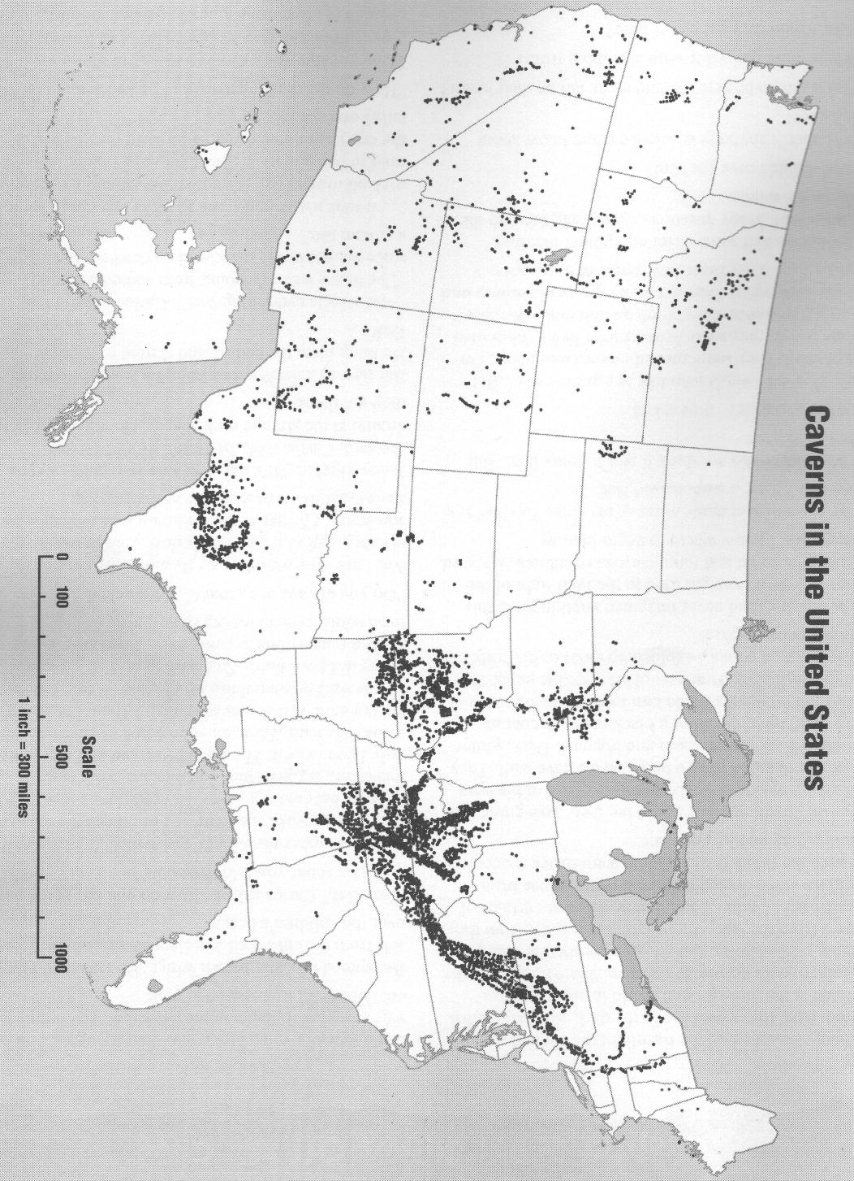

From USGS Exploring Caves Kit

At least 277 sites in Europe are renowned for their cave art, created between 40,000 to 10,000 B.C. Some of the best-known were created by what are called the Magdalenians (from the name of a site), peoples who flourished in Europe from 18,000 to 10,000 BC. Although once major tourism sites, many are now off limits to the public due to the corrosive effects of exposing the caves to the atmosphere and to the carbon dioxide humans respire. Some of the cave art is sophisticated and superb, indicating that expertise and training were required. Some galleries extend for hundreds of feet through many caves. We may never know why, but the most accepted theories of creating this art are satisfaction, and a sense of entertainment, fun, knowledge and spirituality.

Another famous find was the discovery of fossils belonging to giant, extinct animals in the Wellington Caves, Australia, by Sir Thomas Mitchell of England in 1838. The fossils became world renown, studied by Charles Darwin and other scientists.

Caves have also been used for more utilitarian devices. They have been used as garbage dumps (out of sight, out of mind), for storage, or as hideouts during wars. They were excavated for nitrates, an important ingredient in gunpowder needed in the Civil War. Even bat guano is mined as a phosphate fertilizer. Roquefort blue cheese is made in the unique climatic conditions of certain caves. Ore minerals have been mined in caves. They are also used as a source of water for irrigation and hydroelectricity. Studies are underway in Europe to test using caves for domestic cold storage, air conditioning, and water supply purposes.

Groundwater Contamination
One of the many reasons scientists study caves is to understand their bearing on underground water systems, since cavernous limestone deposits are among the most productive aquifers in the U.S. Use of the land above caves makes it necessary to study ground stability to prevent ground failure or subsidence. The depletion of cave aquifers has led to vast sinkholes that swallow up houses or even city blocks. Another major problem is groundwater contamination. Streams flowing through caves are susceptible to contaminants from the surface. Shallow aquifers in karst areas are probably the most vulnerable in the world to groundwater contamination. Because of the rapid velocities of these underground streams, contaminants may travel several miles through the aquifer in only a few hours as shown by dye traces. Contaminants associated with agricultural activities, such as nitrates, bacteria from livestock waste, and pesticides, are potential problems in karst terrain. Urban storm water runoff can contain lead, chromium, oil, grease, and bacteria from animal wastes which may be a threat to people using karst water supplies and to cave aquatic life.
Contamination problems are aggravated in karst areas by the practice of disposing of solid and liquid wastes in sinkholes where they may be washed directly into the aquifer. The recent development and widespread use of hazardous materials has increased the threat from this practice. Leaks, spills, or deliberate dumping of toxic or explosive chemicals are particularly serious hazards in karst areas. Not only are these materials a threat to water supplies and cave aquatic life, but upon vaporizing they may become highly concentrated in the cave atmosphere, rise through fractures in the limestone and enter inhabited structures on the surface. Chemicals that leak from underground tanks may be carried into the caves below by water percolating through soil following heavy rains. Some caves become completely water-filled at some point downstream. This results in natural traps for floating chemicals such as gasoline, which accumulate against the ceiling since they cannot continue with the cave stream past these sumps. Fumes may then fill the cave and rise into buildings on the surface. Occasionally homes in urban areas must be evacuated because fumes reach explosive levels in basements. Vigilance of groundwater in cave and karst systems is quickly becoming high priority in those areas that depend on the aquifers in these systems.

Cave Tourism
Unfortunately, human entrance into caves inevitably affects the fragile system. Even the most careful scientists cause change and damage to a cave ecosystem. Some visitors cause even more damage by writing graffiti, breaking and removing speleothems, and leaving garbage behind. Every visitor expels excess carbon dioxide, raises the temperature of the system, sheds minute particles such as dead skin, hair, and clothing fibers, and leaves behind bacteria and fungi when we cough or from our shoes, altering the chemistry of the cave. This alteration can cause native species to become extinct and may change the types of animals living in the cave.

Caves in the U.S.
The United States has a large number of cave systems, and many that are quite impressive. The longest is the Mammoth-Flint Ridge Cave system in Kentucky with more than 350 passable miles! Other impressive caves in the U.S. are Jewel Cave in South Dakota, Organ Cave in West Virginia, and Wind Cave in South Dakota. Although the ranking of the world’s longest caves is not changing rapidly, great discoveries are currently being made, causing changes in the list of the deepest caves of the world. These discoveries are occurring mainly in Eastern Europe and Mexico. The official list of the world’s longest and deepest caves is located on the National Speleological Society (NSS) Long and Deep Cave List, maintained by the NSS Geology and Geography Section: http://www.pipeline.com/~caverbob/.

There are also a large number of “show caves” where the general public can view the wonders of a cave in easy and comfortable conditions, such as Carlsbad Caverns National Park in NM and Mammoth Cave National Park in KY. There are in fact 40 countries in the world that maintain show caves. For a full list of show caves in the U.S and the world, visit the Web sites: http://www.showcaves.com; or http://cavern.com/caves.htm from the American Caves Assoc.; or http://www.showcaves.com/english/Caves.html.

CAVE CONSERVATION
The value of caves has only recently become understood. They are very important to water systems, are easily contaminated, and often have unique species, fossils, or other formations. People admire caves’ natural beauty and demanding terrain.

Unfortunately, as discussed previously, caves are also easily damaged. Humans use them to dump garbage, waste, or pollution. Sometimes the limestone that the caves are formed in is mined, destroying the caves in the process. Altering the type of or amount of water flowing into the cave can also destroy the cave or species and formations within it. This can occur with the building of dams or the redirecting of waterways.

The United States recognizes the danger humans are to caves, and in 1988 passed a law that helped protect them:

The Federal Cave Protection Act of 1988:
The Congress finds and declares that-- (1) significant caves on Federal lands are an invaluable and irreplaceable part of the Nation's natural heritage; and (2) in some instances, these significant caves are threatened due to improper use, increased recreational demand, urban spread, and a lack of specific statutory protection.
(b) PURPOSES.--The purposes of this Act are-- (1) to secure, protect, and preserve significant caves on Federal lands for the perpetual use, enjoyment, and benefit of all people; and (2) to foster increased cooperation and exchange of information between governmental authorities and those who utilize caves located on Federal lands for scientific, education, or recreational purposes.
(c) POLICY.--It is the policy of the United States that Federal lands be managed in a manner which protects and maintains, to the extent practical, significant caves.

In addition to the Federal Law, there are 27 states with cave protection laws. Texas has a bat protection law in addition to a cave protection law. The definition of a cave varies widely by state. The definition ranges from a "historic site," as defined in Vermont, to Kentucky's definition of “any naturally occurring void, cavity, recess, or system of interconnecting passages beneath the surface of the earth containing a black zone including natural subterranean water and drainage systems, but not including any mine, tunnel, aqueduct, or other man-made excavation, which is large enough to permit a person to enter.”

Penalties for vandalism, removing any materials found in caves, killing or removing plant and animal life, breaking or tampering with doors or gates are classified in every state as a misdemeanor. The penalty is either criminal or civil and ranges from $50 to $2,000 and/or up to one-year imprisonment. A subsequent violation either increases the penalty or becomes a criminal felony.

Groups that help conserve caves
There are a number of societies or groups that help to conserve caves.

The National Speleological Society (NSS)
NSS is the “world's largest organization dedicated to the exploration, conservation and study of caves. The NSS was founded in 1941 and its headquarters are located in Huntsville, AL. Its members have discovered, explored and studied more than 40,000 caves in the United States, as well as conducted extensive research and exploration in caves throughout the world. The NSS includes more than 12,000 active members with interests ranging from recreation to research, and whose efforts have contributed extensively to understanding our nation's cave resources.” (http://www.caves.org)

NSS Conservation Policy

The National Speleological Society believes:
- Caves have unique scientific, recreational, and scenic values
- These values are endangered by both carelessness and intentional vandalism
- These values, once gone, cannot be recovered
- The responsibility for protecting caves must be formed by those who study and enjoy them.

Accordingly, the intention of the Society is to work for the preservation of caves with a realistic policy supported by effective programs for: the encouragement of self-discipline among cavers; education and research concerning the causes and prevention of cave damage; and special projects, including cooperation with other groups similarly dedicated to the conservation of natural areas. Specifically:
All contents of a cave -- formations, life, and loose deposits -- are significant for their enjoyment and interpretation. Therefore, caving parties should leave a cave as they find it. They should provide means for the removal of waste; limit marking to a few, small, and removable signs as are needed for surveys; and, especially, exercise extreme care not to accidentally break or soil formations, disturb life forms or unnecessarily increase the number of disfiguring paths through an area.
Scientific collection is professional, selective, and minimal. The collecting of mineral or biological material for display purposes, including previously broken or dead specimens, is never justified, as it encourages others to collect and destroy the interest of the cave.
The Society encourages projects such as:
- Establishing cave preserves
- Placing entrance gates where appropriate
- Opposing the sale of speleothems
- Supporting effective protective measures
- Cleaning and restoring over-used caves
- Cooperating with private cave owners by providing them knowledge about their cave and assisting them in protecting their cave and property from damage during cave visits
- Encouraging commercial cave owners to make use of their opportunity to aid the public in understanding caves and the importance of their conservation.
Where there is reason to believe that publication of cave locations will lead to vandalism before adequate protection can be established, the Society will oppose such publication.
It is the duty of every Society member to:
Take personal responsibility for spreading a consciousness of the cave conservation problem to each potential user of caves. Without this, the beauty and value of our caves will not long remain with us.

The American Cave Conservation Association (ACCA)
ACCA is a nonprofit organization formed in 1977 for the purpose of protecting caves and karst lands. “ACCA is committed to developing public education programs and professional services that promote land use planning and proper stewardship of underground natural resources”. In 1986, ACCA moved its headquarters from Richmond, Virginia to Horse Cave, Kentucky with the goal of building a unique, national educational center to address cave, karst and groundwater problems. ACCA raised more than $1.4 million from grants and donations in order to open the Center in 1993. This Center includes the American Cave Museum.

ACCA has designed more than 100 cave gates for protection of endangered species and archaeological sites. Training seminars have taught hundreds of land managers how to take care of caves effectively. For nearly two decades, ACCA has worked in partnership with agencies and organizations such as the National Park Service, the U.S. Forest Service, the U.S. Fish and Wildlife Service, the Nature Conservancy and the NSS to protect some of the most significant cave ecosystems in America.” (http://www.cavern.org/acabout.htm)

The National Caving Association
The National Caving Association has developed a cave conservation code that they hope all cavers will follow. The code includes the following:

Cave with care and within your abilities - A moment of carelessness, perhaps caused by fatigue, can ruin formations and sediment deposits that are thousands of years old. Always look before you touch or tread. When leading others, your planned trip should be appropriate for the capabilities of the group.

Keep to marked routes and do not cross conservation tapes and barriers - Recommended routes through may be marked and areas of the cave or sometimes whole passages may be taped off to protect formations, items of scientific interest or simply to preserve untrodden areas of cave for future generations. Stay on the correct side of the tape, keep to the route and if in doubt, don't proceed.

Protect cave wildlife and do not disturb bats - Many creatures live in caves and often go unnoticed by passing cavers. The environment is fragile and care must be taken not to disturb it by, for example, dropping food or polluting water. Bats are among some of Britain's most endangered species and are given special protection in law. If seen in a cave they should be left alone and passed as quickly and quietly as possible.

Do not pollute the cave, leave nothing behind - Except under exceptional circumstances, nothing that is taken into a cave should ever be left in. Take out all litter, food and waste. Because of the toxic waste produced by carbide lamps, this type of lighting is now discouraged and electric lighting is preferred.

Archaeological and other remains should not be disturbed - The cave environment often contains important paleontological and archaeological remains. These may include industrial and pre-industrial artifacts. They should not be disturbed and only investigated by competent specialists.

Do not interfere with scientific equipment - To study the cave environment it is often necessary to leave expensive and fragile equipment underground. Disturbing this may damage the equipment and destroy valuable work.

Set a good example for others to follow - One way to pass on good conservation practices to others is through education and setting a good personal example. Be responsible, show an interest and understanding of caving and demonstrate the cave conservation code in action.

Avoid touching or damaging formations - It is sometimes tempting to touch formations because they look so inviting. This should be avoided because the formations will be soiled. Each individual caver may notice no difference from a single touch but hundreds or even thousands of grubby fingers will completely ruin beautiful formations. It should be remembered that formations are not always made of pretty crystals; they may be mud, sand or rock and all should be treated with the same respect.

Take nothing but photographs - Nothing, except for litter left by the careless, should ever be removed from a cave. Broken formations and other geological specimens including rocks should be left untouched.

Comply with any access requirements - Different caves have different rules both for obtaining access and for the correct way to behave in the cave. These rules are designed to help with cave conservation and every caver should support this aim by following any guidelines. Group leaders should make certain that the whole group understands and follows any guidelines.

Respect the rights and privacy of land owners - All cave entrances are on land belonging to someone. Sometimes cavers have special access arrangements with statutory conservation bodies, but more often we rely on the good will of the land owner. Always remember that the land owner has the right to deny access; respect their privacy and comply with any access conditions or risk losing access for all.

Follow the NCA Minimum Impact Caving Code and Code of Ethics - These Codes are designed to advice on the best means of protecting the cave environment and access to it. Copies are available from the NCA. http://www.caveinfo.org.uk/nca/canda/concode.htm

REFERENCES & RESOURCES:
Bryant, Chris, “Deep Secrets: Caves, Ocean Floor Give Geologists Weather Reports from Thousands of Years Ago,” The University of Alabama Research Magazine Online, Vol. 6, Issue 1, 2002: http://research.ua.edu/archive2002/secrets1.html#top.

Cave Minerals of the World, by Carol Hill and Paolo Forti, 2nd ed., National Speleological Society, 1997.

Cave Paintings: http://www.artchive.com/artchive/C/cave.html; from “Art: A New History” by Paul Johnson.

Cole, Julia, “Treasures in a Pristine Cave”, Geotimes, 1991:
http://www.geotimes.org/oct99/newsnotes.html

Discovering Caves: Australian Geological Survey Organisation, Canberra, ACT. 2000

Gander Academy’s Cave Theme Page: http://www.cdli.ca/CITE/cave.htm#Types

Indiana Karst Conservancy: http://www.caves.org/conservancy/ikc/karst.htm

Introduction to Karst Environmental Problems; Groundwater Contamination; Western Kentucky University, http://www.dyetracing.com/karst/ka01013.html

Linacre, E., 1998, Stalagmites and past climates;
http://www-das.uwyo.edu/~geerts/cwx/notes/chap15/stalgmites.html

NASA: Astrobiology Magazine: Search for Life in the Universe: Cave Slime: http://www.nasa.gov/vision/universe/solarsystem/cave_slime.html

National Cave and Karst Research Institute (NCKRI), http://www2.nature.nps.gov/nckri/

National Speleological Society, Inc.: http://www.caves.org/
FREE brochures: www.caves.org/brochure

Northup, Diana E., et al., Microbially Influenced Corrosion in Lechuguilla and Spider Caves. Microbiological Interactions of Microbial Communities in Cave Deep Subsurface Environments: a Novel Extreme Environment;
http://www.i-pi.com/~diana/slime/corrosion/

Nova, The Mysterious Life of Caves: http://www.pbs.org/wgbh/nova/caves/

Powell, Eric A., “Caves and Climate”, Archaeology, Vol. 55, No. 1, Jan/Feb 2002.

Project Underground, Inc. A K-12 education program. Contact Carol Zokaites zokaites@usit.net

The Virtual Cave, by Dave Bunnell. http://www.goodearthgraphics.com/virtcave/index.html

University of Missouri St. Louis: Ozark Caving: http://www.umsl.edu/~joellaws/ozark_caving/

USGS: Geology of Caves: http://www2.nature.nps.gov/geology/usgsnps/cave/cave.html

USGS: lava tubes: http://vulcan.wr.usgs.gov/Glossary/LavaTubes/description_lava_tubes.html

Others related Web sites;
www.cavern.org
www.caves.org.au
www.bci.org
www.caves.org

